FULL STACK WEB DEVELOPMENT
ASSIGNMENT – 2
MONGODB – STUDENT INFORMATION MANAGEMENT SYSTEM

Submitted By
Ch Venu Gopal Reddy
Roll Number: A24126552078

Subject
Full Stack Web Development
Academic Assignment

Objective
Develop a simple system to store, retrieve, update, and manage student information using MongoDB.

MongoDB Installation and Setup
Before performing the assignment, MongoDB Server and MongoDB Shell (mongosh) should be installed. The following checks can be performed in PowerShell or the VS Code terminal.

1. Check MongoDB Shell
mongosh --version
The installed MongoDB Shell version should be displayed.

2. Check MongoDB Server Service
Get-Service MongoDB
The MongoDB service should show Running when the server is active.

3. Open MongoDB Shell
mongosh
After a successful connection, the mongosh prompt is displayed.
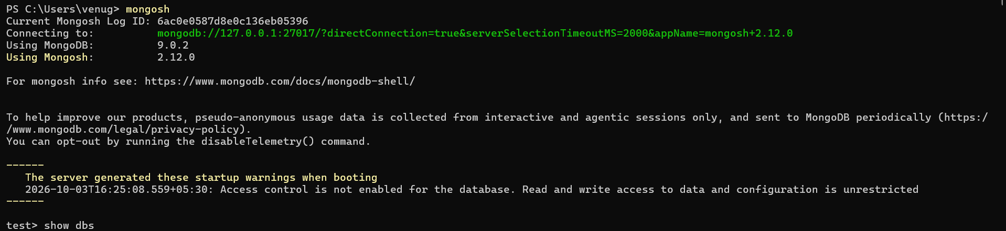

Student Task
Create a MongoDB database named:
collegeDB
Create a collection named:
students
Each student document should contain:
{
rollNo: "23CM001",
name: "Ravi Kumar",
branch: "CSE-AIML",
year: 3,
marks: 85,
email: "ravi@example.com"
}

1. Create Database and Collection
Select collegeDB and explicitly create the students collection.
MongoDB Commands:
use collegeDB
db.createCollection("students")
show collections
Expected Output / Screenshot:
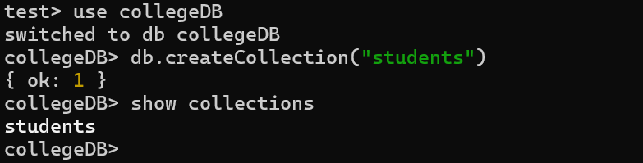

2. Insert Student Records
Insert five student records so that all required operations can be demonstrated.
MongoDB Commands:
db.students.insertMany([
{ rollNo:"23CM001", name:"Ravi Kumar", branch:"CSE-AIML", year:3, marks:85, email:"ravi@example.com" },
{ rollNo:"23CM002", name:"Anita Sharma", branch:"CSE", year:2, marks:92, email:"anita@example.com" },
{ rollNo:"23CM003", name:"Kiran Reddy", branch:"ECE", year:3, marks:68, email:"kiran@example.com" },
{ rollNo:"23CM004", name:"Priya Singh", branch:"CSE-AIML", year:4, marks:45, email:"priya@example.com" },
{ rollNo:"23CM005", name:"Arjun Rao", branch:"IT", year:2, marks:78, email:"arjun@example.com" }
])
Expected Output / Screenshot:
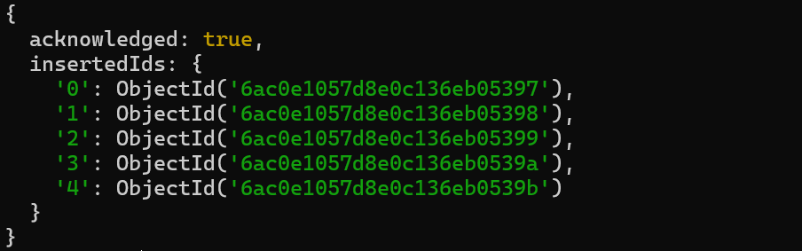

3. Display All Students
Use find() to display all student documents.
MongoDB Commands:
db.students.find()
Expected Output / Screenshot:
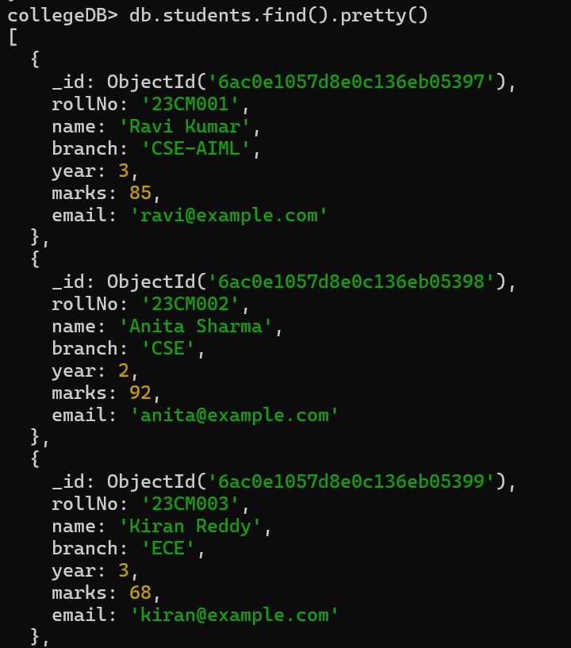
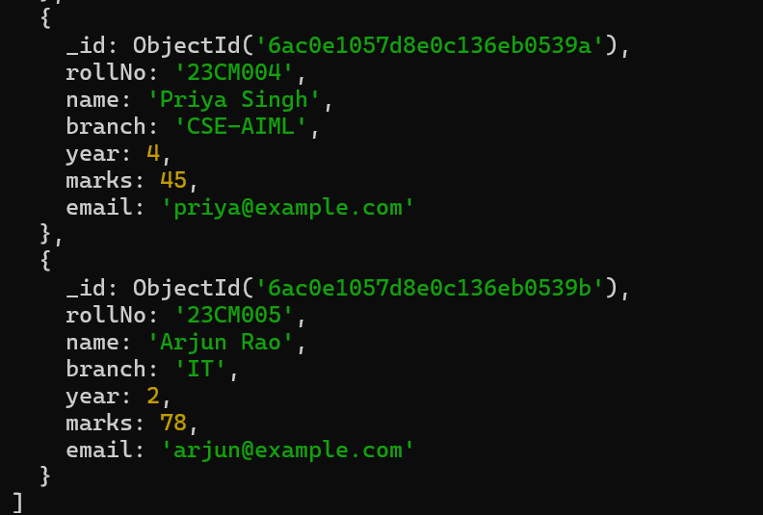

4. Display Students Belonging to a Particular Branch
Display students belonging to the CSE-AIML branch.
MongoDB Commands:
db.students.find({ branch: "CSE-AIML" })
Expected Output / Screenshot:
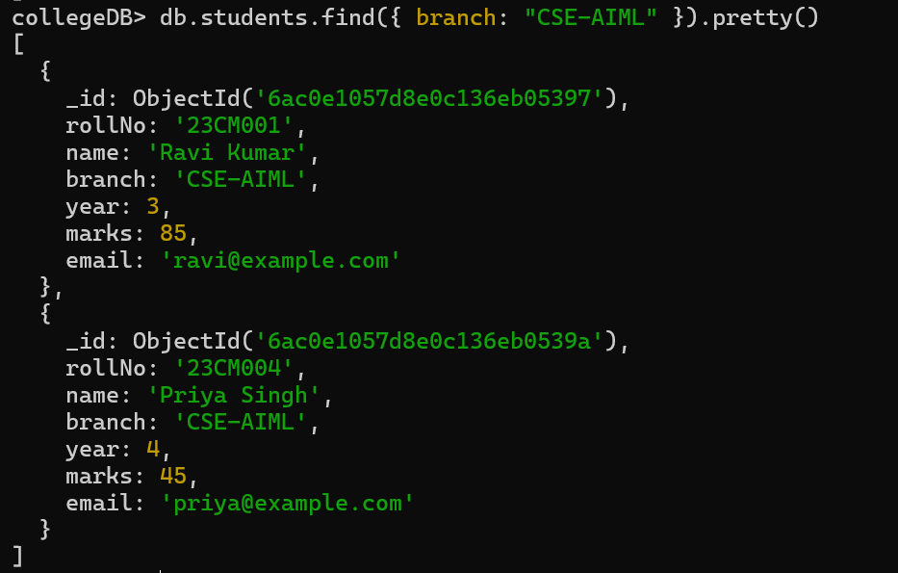

5. Display Students Who Scored More Than 75 Marks
Use $gt to find marks greater than 75.
MongoDB Commands:
db.students.find({ marks: { $gt: 75 } })
Expected Output / Screenshot:
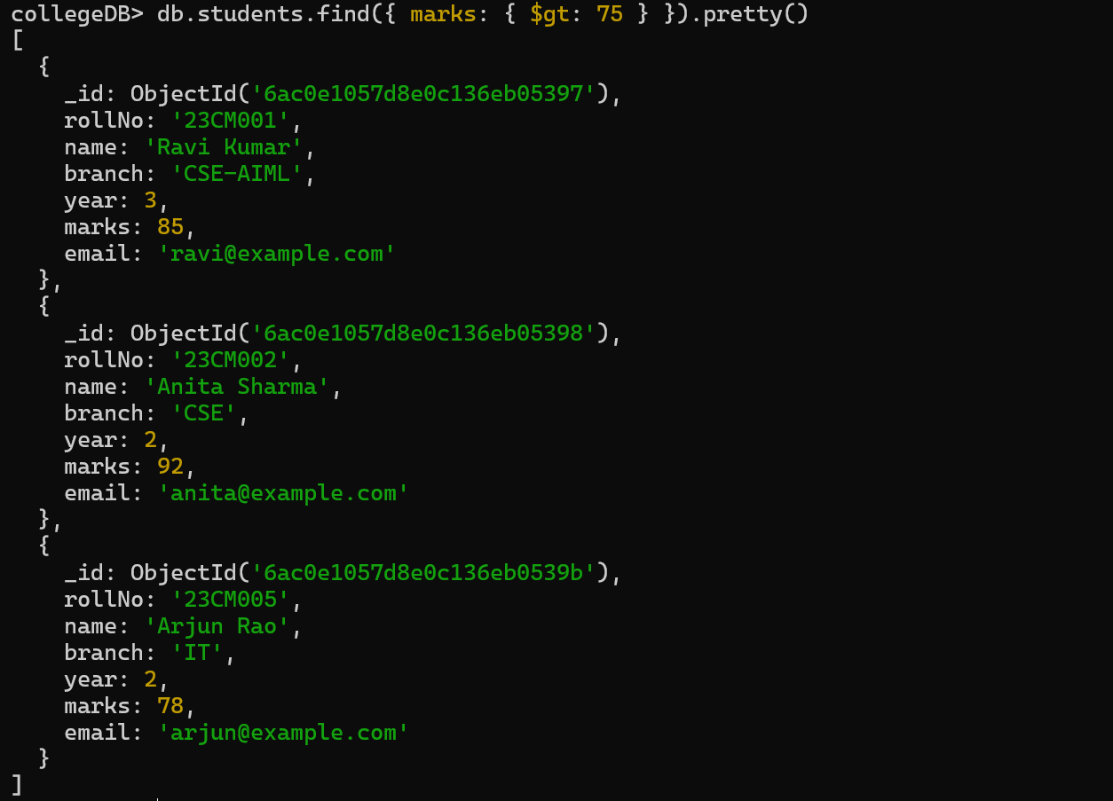

6. Search for a Student Using rollNo
Find one student using the rollNo field.
MongoDB Commands:
db.students.findOne({ rollNo: "23CM001" })
Expected Output / Screenshot:
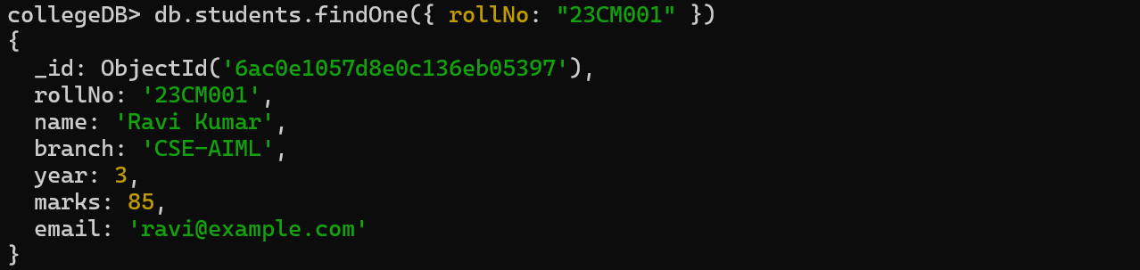

7. Search Students Based on a Specified Condition
Search using conditions on year and marks.
MongoDB Commands:
db.students.find({ year: 3 })
db.students.find({ marks: { $gte: 80 } })
Expected Output / Screenshot:
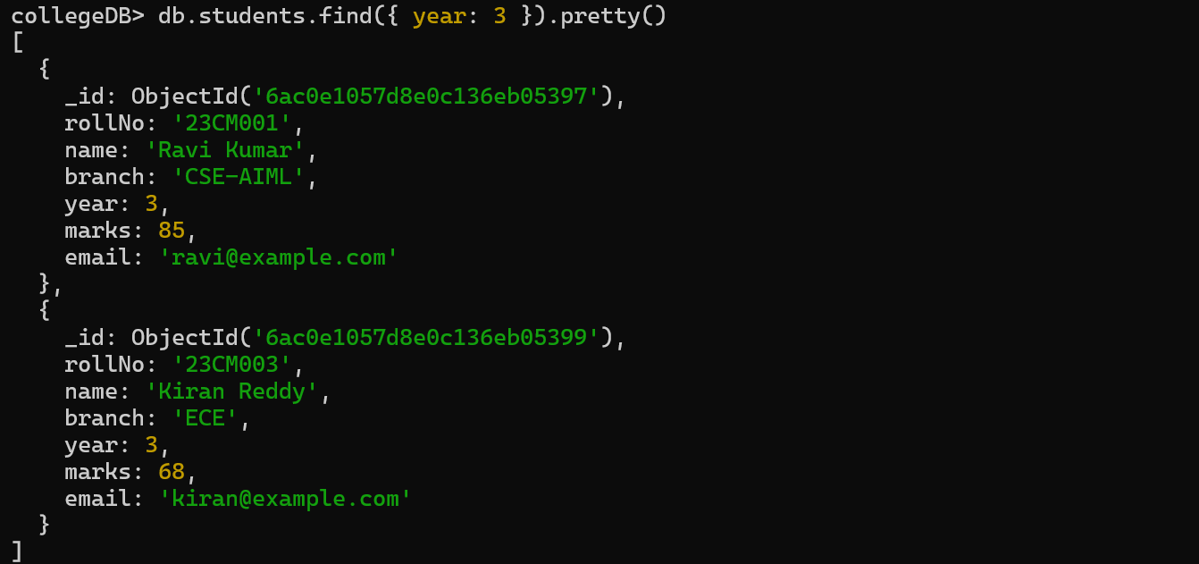
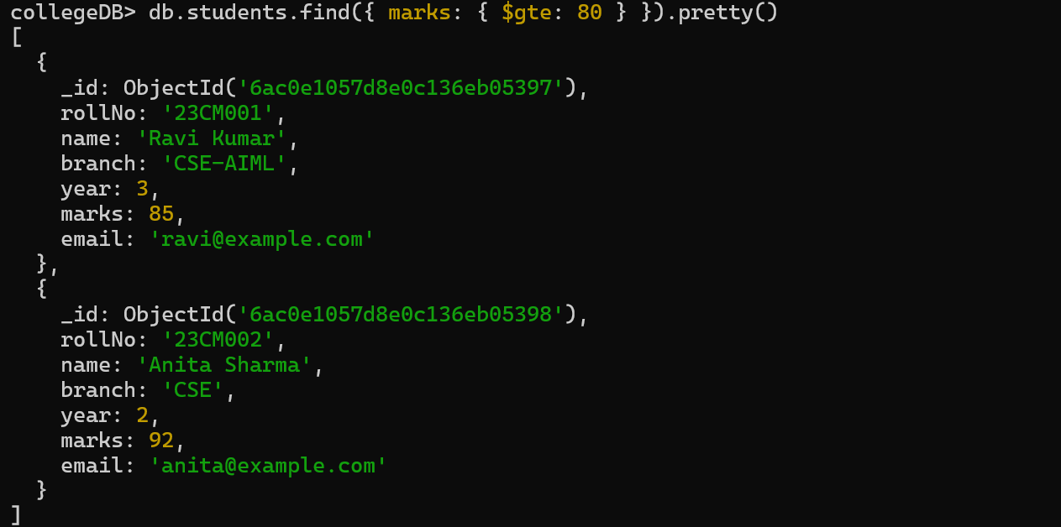

8. Update the Marks of a Particular Student
Update Ravi Kumar's marks from 85 to 90 and verify the record.
MongoDB Commands:
db.students.updateOne(
{ rollNo: "23CM001" },
{ $set: { marks: 90 } }
)
db.students.findOne({ rollNo: "23CM001" })
Expected Output / Screenshot:
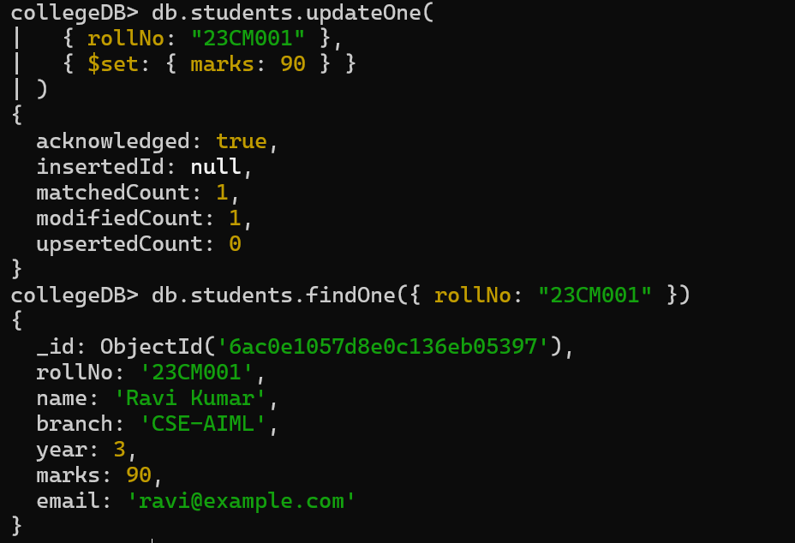

9. Update Another Field – Email
Update Kiran Reddy's email and verify the record.
MongoDB Commands:
db.students.updateOne(
{ rollNo: "23CM003" },
{ $set: { email: "kiran.reddy@example.com" } }
)
db.students.findOne({ rollNo: "23CM003" })
Expected Output / Screenshot:
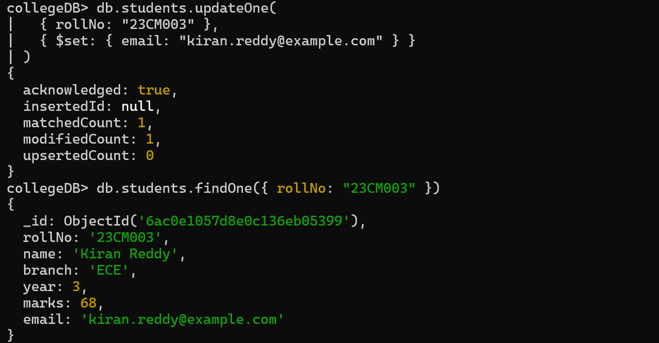

10. Delete a Student Record Using rollNo
Delete the record with rollNo 23CM005 and verify the remaining records.
MongoDB Commands:
db.students.deleteOne({ rollNo: "23CM005" })
db.students.find()
Expected Output / Screenshot:
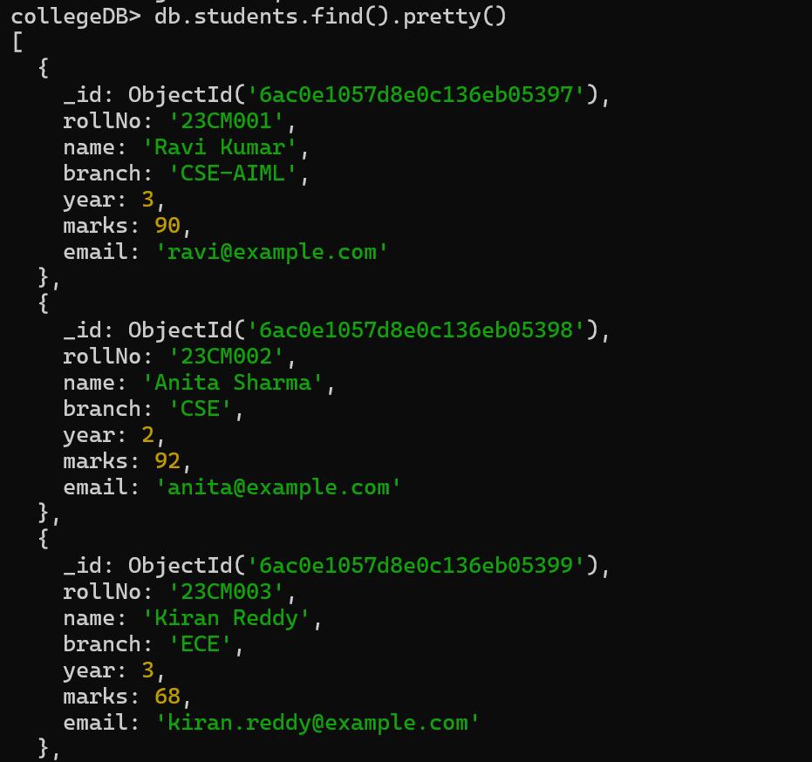
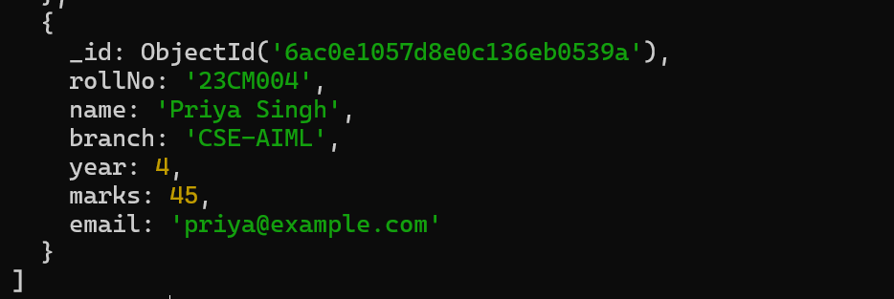

11. Display Students in Descending Order of Marks
Use sort({marks:-1}) to display highest marks first.
MongoDB Commands:
db.students.find().sort({ marks: -1 })
Expected Output / Screenshot:
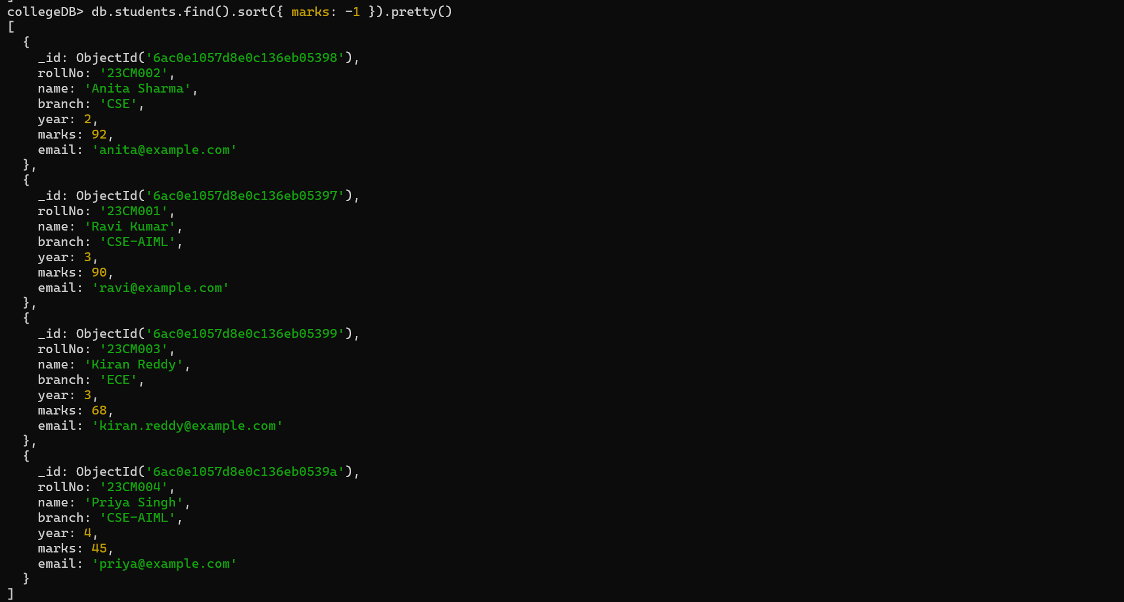

12. Create an Index on rollNo
Create an index on rollNo and display the collection indexes.
MongoDB Commands:
db.students.createIndex({ rollNo: 1 })
db.students.getIndexes()
Expected Output / Screenshot:
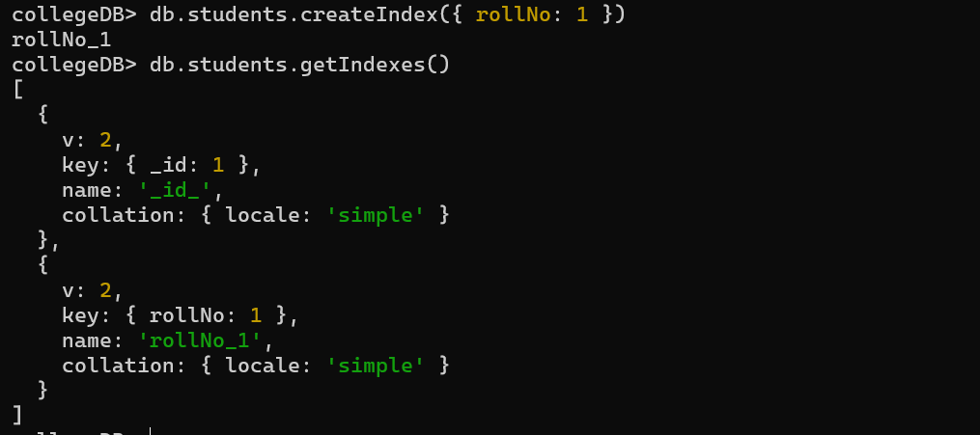

13. Demonstrate Why Indexing Is Useful
Use explain() to inspect the execution plan for a rollNo search. An index scan such as IXSCAN can demonstrate index usage.
MongoDB Commands:
db.students.find({ rollNo: "23CM001" }).explain("executionStats")
Expected Output / Screenshot:
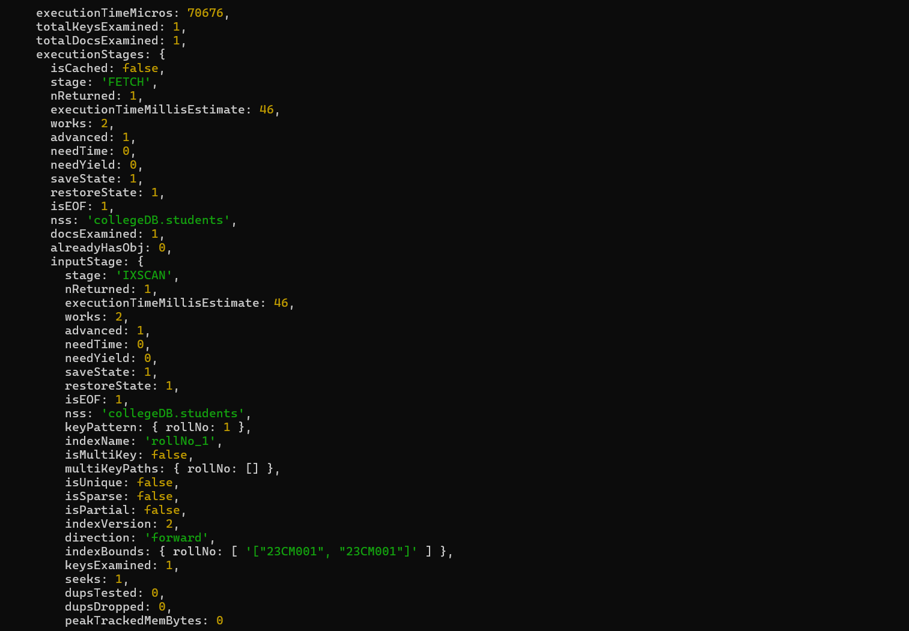

Real-Time Extension ⭐
Perform additional queries on the student records.

14. Find Students Scoring Above 80
Find students with marks greater than 80.
MongoDB Commands:
db.students.find({ marks: { $gt: 80 } })
Expected Output / Screenshot:
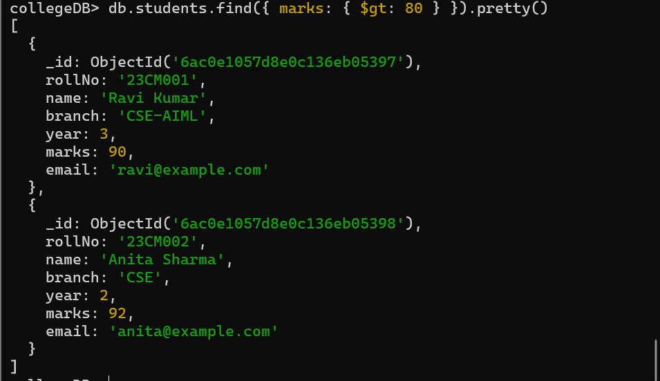

15. Find Students Scoring Below 50
Find students with marks less than 50.
MongoDB Commands:
db.students.find({ marks: { $lt: 50 } })
Expected Output / Screenshot:
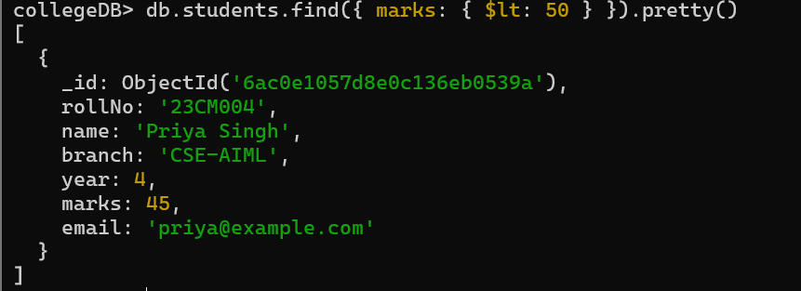

16. Find the Highest-Scoring Student
Sort by descending marks and limit the result to one student.
MongoDB Commands:
db.students.find().sort({ marks: -1 }).limit(1)
Expected Output / Screenshot:
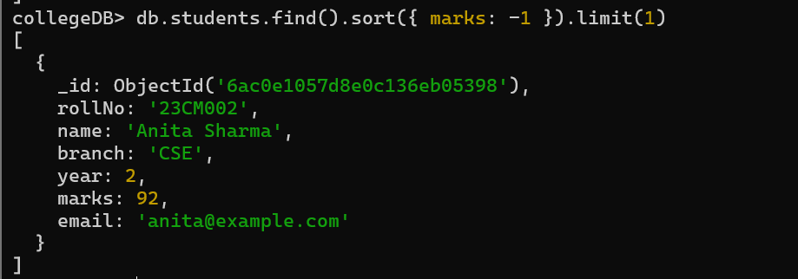

17. Find Students Belonging to a Particular Branch
Find students from CSE-AIML.
MongoDB Commands:
db.students.find({ branch: "CSE-AIML" })
Expected Output / Screenshot:
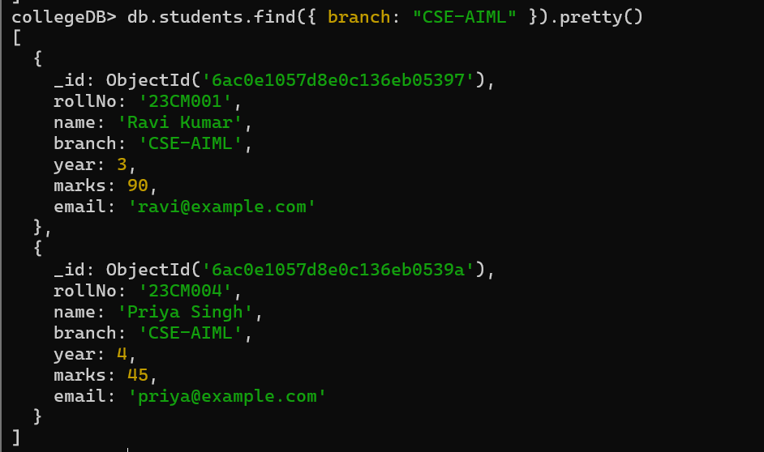

18. Display Students Sorted According to Marks
Display students in ascending order of marks.
MongoDB Commands:
db.students.find().sort({ marks: 1 })
Expected Output / Screenshot:
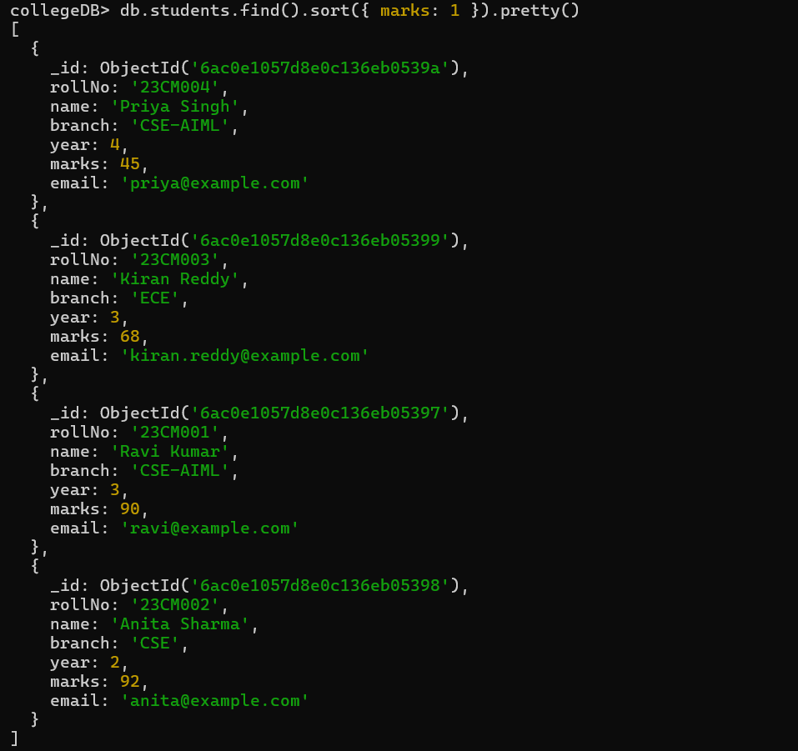

19. Final Display of Student Records
Display the final student records after the update and delete operations.
MongoDB Commands:
db.students.find()
Expected Output / Screenshot:
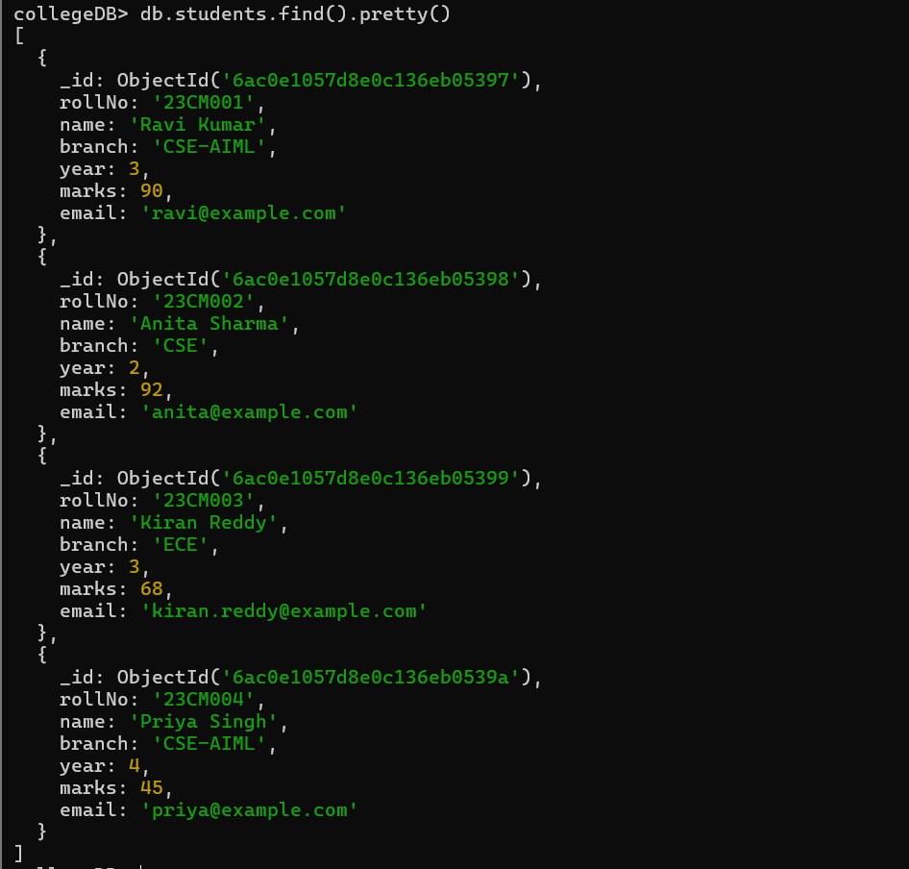

How to Run the MongoDB Assignment in VS Code
1. Install MongoDB Server and MongoDB Shell if they are not already installed.
2. Open Visual Studio Code and open the integrated terminal.
3. Check the shell using mongosh --version.
4. Check the MongoDB service using Get-Service MongoDB.
5. Open the shell using mongosh.
6. Enter the MongoDB commands from this assignment one by one.
7. Take screenshots of the commands and their outputs and paste them into the provided spaces.
Note: If the students collection already exists from an earlier attempt, createCollection may report that it already exists. In that case, continue with the required operations rather than creating a duplicate collection.

Conclusion
The MongoDB student information management system was implemented to store, retrieve, update, search, sort, and delete student records. Branch, marks, year, and rollNo queries were demonstrated. An index was created on rollNo and explain() was used to inspect index usage. The real-time extension queries were also performed.

